MADHAV INSTITUTE OF TECHNOLOGY AND SCIENCE, GWALIOR

SUBMITTED BY-

ASMITA JAIN

0901EO201017

SUBMITTED TO-

PROF. APRAJITA KUMARI

**SENSOR TECHNOLOGY LAB 220202**

**EXPERIMENT - 9**

**AIM:**

TO STUDY ABOUT THE PRINCIPLE OF HALL EFFECT SENSOR AND ITS APPLICATIONS.

**APPARATUS REQUIRED:**

* DIGIAC 1750 Transducer and Instrumentation Trainer.
* 4mm Connecting Leads.
* Digital Multimeter.

**THEORY:**

*WORKING PRINCIPLE*:

Hall effect sensors work on the principle that when a beam of charge particles passes through a magnetic field, forces act on the particles and the current beam is deflected from its straight-line path. Thus, one side of the disc will become negatively charged and the other side will be of positive charge. This charge separation generates a potential difference which is the measure of distance of magnetic field from the disc carrying current.

When the device is placed within a magnetic field, the magnetic flux lines exert a force on the semiconductor material which deflects the charge carriers, electrons and holes, to either side of the semiconductor slab.

*CONSTRUCTION MATERIAL:* Hall Effect Sensors consist basically of a thin piece of rectangular p-type semiconductor material such as gallium arsenide (GaAs), indium antimonide (InSb) or indium arsenide (InAs) passing a continuous current through itself.

**CIRCUIT DIAGRAM:**

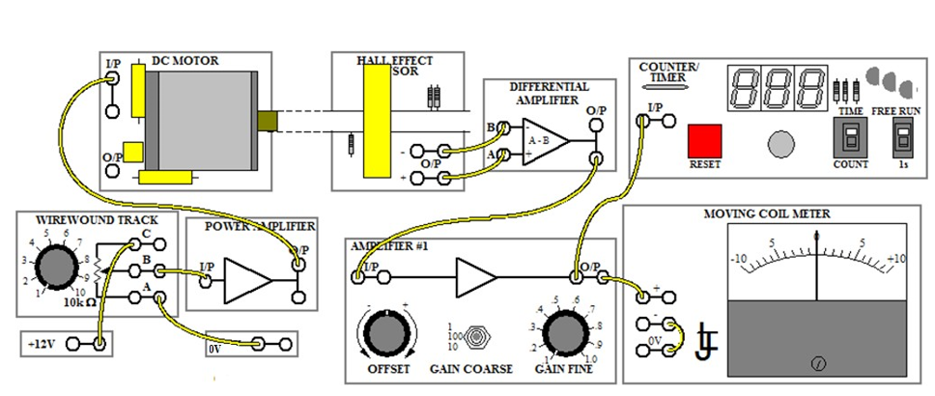

**OBERSERVATION TABLE:**PART 1-VERIFYING PRINCIPLE OF HALL EFFECT SENSOR

|  |  |  |  |
| --- | --- | --- | --- |
| **Magnetic field** | **Digital multimeter** | | **Moving coil meter** |
| **Output V (-)** | **Output V (+)** |
| None | 2.089 | 2.138 | 0 V |
| Maximum | 2.589 | 1.645 | 7.5 |

PART 2- FINDING ROTATIONAL SPEED

|  |  |  |  |  |
| --- | --- | --- | --- | --- |
| **Motor voltage** | 2V | 4V | 8V | 10V |
| **Revolution/sec** | 8 | 17 | 35 | 45 |

**RESULT:**

Hence, we have verified the principle of Hall Effect sensor and its application.